## Wednesday, March 09, 2011

### [Sewa Bharti organises free neurotherapy camp](http://www.sewabharathi.com/2011/03/sewa-bharti-organises-free-neurotherapy.html)

[Listen to this article. Powered by Odiogo.com](javascript:showOdiogoReadNowFrame%20('88138',%20'sewa%20bharti%20organises%20free%20neurotherapy%20camp',%20'0',%20290,%2055);)

Source: [tribune India[http://i.ixnp.com/images/v6.59/t.gif](http://www.tribuneindia.com/2011/20110307/region.htm)](http://www.tribuneindia.com/2011/20110307/region.htm)

Monday, March 7, 2011,  
BATHINDA  
NEUROTHERAPY CAMP HELD IN CITY: Sewa Bharti organised a free neurotherapy camp at the local Arya Model High School on Sunday. The camp was inaugurated by chief guest DK Garg. Head of the organization Kamal Kumar Garg thanked the people for their trust and support as the organisation completed its seventh year. Neurotherapist Ajay Kumar spoke about the benefits of the system.

**You might also like:**

* [Sewa Bharti, Bathinda, organised a free medical camp[http://i.ixnp.com/images/v6.59/t.gif](http://sevabharathi.blogspot.com/2008/05/sewa-bharti-bathinda-organised-free.html)](http://sevabharathi.blogspot.com/2008/05/sewa-bharti-bathinda-organised-free.html)
* [Sewa Bharti organises Homeopathic medical camp](http://www.sewabharathi.com/2011/02/sewa-bharti-organises-homeopathic.html)
* [A two day LMNT camp was organized at Agra[http://i.ixnp.com/images/v6.59/t.gif](http://sevabharathi.blogspot.com/2008/11/two-day-lmnt-camp-was-organized-at-agra.html)](http://sevabharathi.blogspot.com/2008/11/two-day-lmnt-camp-was-organized-at-agra.html)
* [Sewa Bharti determined to serve humanity: Kahlon](http://www.sewabharathi.com/2011/01/sewa-bharti-determined-to-serve.html)
* [Administration honours Sewa Bharti for serving society](http://www.sewabharathi.com/2011/02/administration-honours-sewa-bharti-for.html)

[**LinkWithin**[http://i.ixnp.com/images/v6.59/t.gif](http://www.linkwithin.com/learn?ref=widget)](http://www.linkwithin.com/learn?ref=widget)

Posted by Explorer at [9:14 PM](http://www.sewabharathi.com/2011/03/sewa-bharti-organises-free-neurotherapy.html) [http://img1.blogblog.com/img/icon18_email.gif](http://www.blogger.com/email-post.g?blogID=10608384&postID=7497927973518082065)

[Email This](http://www.blogger.com/share-post.g?blogID=10608384&postID=7497927973518082065&target=email)

For activities in Kolkata visit :

<http://www.naturelief.in/Activities.php>

For pictures of AshrAM PLS. SEE

http://wikimapia.org/6045049/Neurotherapy-Ashram-Campus

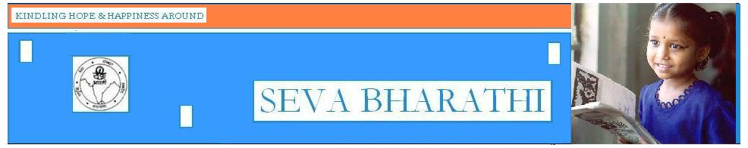

**Thursday, November 06, 2008**

**[A two day LMNT camp was organized at Agra](http://www.sewabharathi.com/2008/11/two-day-lmnt-camp-was-organized-at-agra.html)**

26th & 27th June 2008, by **Sri Ramakant**

Source: [DLMNT](http://www.dlmnt.org/index.php/2008/11/acharyaji-sri-ramchandranjis-visit-to-agra/)

Dixit and Sri Pawan Upadhyay at two different locations in the city. Seva Bharati extended all possible support including permission for me to stay at the Karyalaya premises at Madhav Bhavan, Jaipur House, for which I thanked them, on Guruji’s behalf.

The camp on 26th was essentially for chronic cases who were already taking LMNT treatment, while the camp on 27th was attended by several new patients.

On 27th morning I had a brief informal meeting with some of the officials of Seva Bharati :-

Mananaeeya Suryanarayan Mishraji - Prant Mahamantri,

Sri Jagadeeshji - Prant Prachar Pramukh,

Sri Gangaramji - Kshetra Seva Pramukh,

Sri Raghavenra Tiwariji - Saayam Shakha Pramukh

and Sri Hrishi Kumar ji.

All the above have said that they will motivate eligible students for the future LMNT courses at Suryamal and have requested that they should be sent the application forms for the same.

A total of approx 70 patients received the benefit of my counsel and the LMNT treatment on the two days.

Posted by Explorer at [12:15 PM](http://www.sewabharathi.com/2008/11/two-day-lmnt-camp-was-organized-at-agra.html) [http://img1.blogblog.com/img/icon18_email.gif](http://www.blogger.com/email-post.g?blogID=10608384&postID=6392042949611678851)

[Email This](http://www.blogger.com/share-post.g?blogID=10608384&postID=6392042949611678851&target=email)

Source: <http://www.sewabharathi.com/2008/11/two-day-lmnt-camp-was-organized-at-agra.html>

 [Tamil Nadu](http://www.hindu.com/2009/12/05/23hdline.htm) [[Printer Friendly Page](http://www.hinduonnet.com/thehindu/thscrip/print.pl?file=2009120550900200.htm&date=2009/12/05/&prd=th&)](http://www.hinduonnet.com/thehindu/thscrip/print.pl?file=2009120550900200.htm&date=2009/12/05/&prd=th&)   [[Send this Article to a Friend](http://www.hinduonnet.com/thehindu/thscrip/pgemail.pl?date=2009/12/05/&prd=th&)](http://www.hinduonnet.com/thehindu/thscrip/pgemail.pl?date=2009/12/05/&prd=th&)  
Online edition of India's National Newspaper Saturday, Dec 05, 2009

**Neurotherapy camp to be held**

Staff Reporter

PUDUKOTTAI: Under the auspices of a service organisation, Sama Dhrishti Kshamatha Vikas Evam Anusandhan Mandal (SAKSHAM), a one-day free camp on neurotherapy will be held for the benefit of the physically-challenged and mentally-ill persons on Sunday.

Organiser for South Tamil Nadu unit of the Mandal, Sri Sowmyanarayanan, said that the camp formed part of the observance of the ‘World Diabled Day’ and would be held from 9.30 a.m. at Shirdi Sai Baba Bhajan Mandali on East II Street in the town. For registration, parents could contact 97868-11235.

Source : <http://www.hindu.com/2009/12/05/stories/2009120550900200.htm>

**- - - - - - - - - - - - - - - - - - - - -**



**Monday, March 7, 2011, Chandigarh, India**

**BATHINDA**Neurotherapy camp held in city: Sewa Bharti organised a free neurotherapy camp at the local Arya Model High School on Sunday. The camp was inaugurated by chief guest DK Garg. Head of the organization Kamal Kumar Garg thanked the people for their trust and support as the organisation completed its seventh year. Neurotherapist Ajay Kumar spoke about the benefits of the system.

Source:

http://www.tribuneindia.com/2011/20110307/region.htm



**Monday, October 17, 2005, Chandigarh, India**

**Neurotherapy camp**

Mohali, October 16  
Rotary S.A.S Nagar organised a camp on neurotherapy in association with Scientific Research Institute at Durga Mandir, Phase 6, here today. Starting from today, the camp will continue till October 31.

Dr B.S. Chandhok, president of the club, inaugurated the camp. Mr R.C. Sharma, municipal councillor, presided over. A team of neurotherapists will conduct the camp daily from 8 a.m. to 12 noon on the mandir premises. **TNS**

Source :

<http://www.tribuneindia.com/2005/20051017/cth3.htm>

**- - - - - - - - - - - - - - - - - - - - -**

http://www.hindu.com/thehindu/mp/hindux.gif  
Online edition of India's National Newspaper  
Friday, Jun 17, 2011

**Health camp**

Free natural health camp and counselling for all

Venue: Homeopathy Clinic & Neurotherapy Centre, 48, Anna Nagar

Date: June 19

Time: 9 a.m. to 2 p.m.

Phone: 2527238

Source :

<http://www.hindu.com/mp/2011/06/17/stories/2011061752850200.htm>

|  |
| --- |
|  |
|  |
| |  |  |  | | --- | --- | --- | |  |  |  | |

## Neurotherapy Camp held in Kinnigoli

Last Updated on Sunday, 30 September 2007 00:00 Sunday, 30 September 2007 00:00

Kinnigoli Sep30

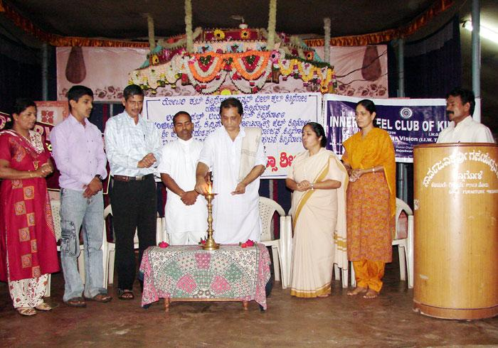  
Neurotherapy camp was conducted today in Kinnigoli under the patronage of Rotary Club, Innerwheel club , Yugapurusha, Lions Club , Lioness club, Sanjivini Trust, Rotaract Club,  Sri Kshetra Dharmasthala Gramabhivruddi Yojane, I.C.Y.M. Kinnigoli and Ujwala Womens cell (Sthrisangatane) Kinnigoli.

Sister Anitha Frank explained about advantage of  Ayurvedic and other medicines. She   also explained about brief history of nuero therapy.

Dr. Kiran , Eric Pais , Prakash Acharya, Sister Anitha Frank, Mallika Poonja Irine Rebello and Bhuvanabirama Udupa were the dignitaries on stage.

Prayer was conducted by Sanjivin Trust Employees  
Welcome was by  Eric Pais  
Vote of Thanks by Mallika Poonja  
Programme was compered by Jayaram Poonja

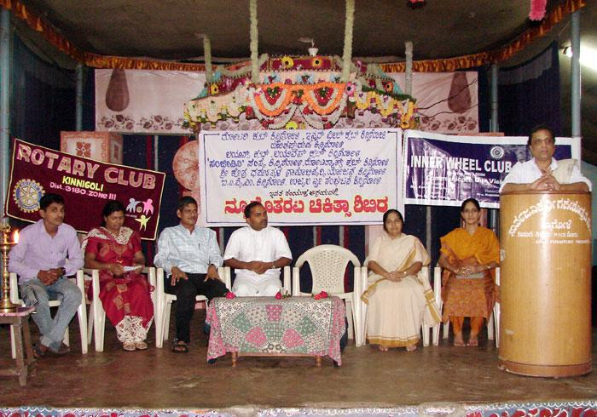

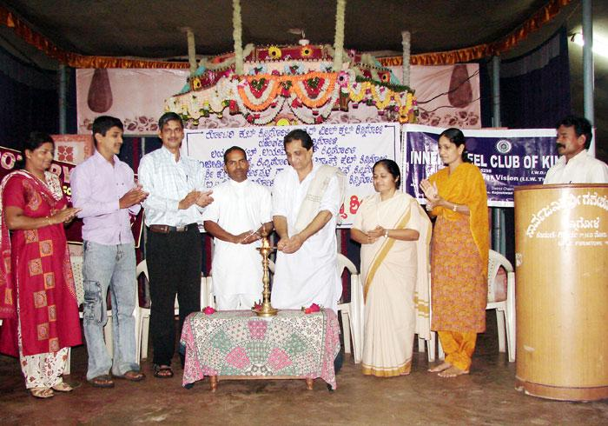

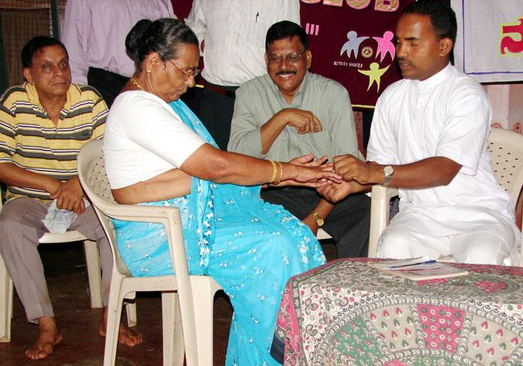

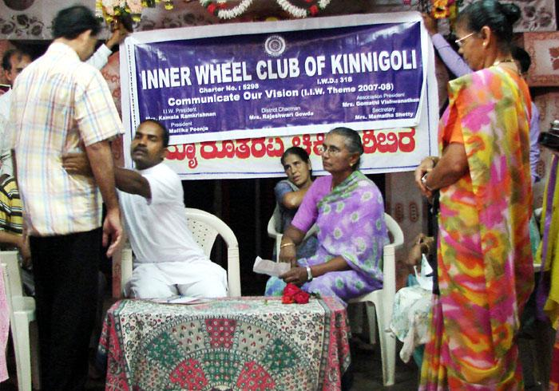

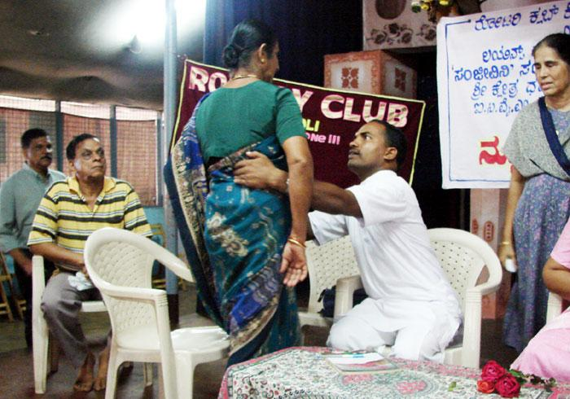

Source:

<http://portal.kinnigoli.com/index.php?option=com_content&view=article&id=1742&catid=1:parish-special-events&Itemid=9>

**- - - - - - - - - - - - - - - - - - - - -**

No. RWA-41/2008-09/Circular-8 Dated: 16.09.2008

Dear Residents,

**R.W.A. 41** in association with Neighbourhood Association (Sector 40-41) is organizing a

NEUROTHERAPY TREATMENT AWARENESS CAMP

On **Saturday, 20th September, 2008 at 9.45 AM**

**Venue: Community Centre, Sector 41, Noida**

(Near J Block, Behind Prayag Hospital)

*The World Renowned* ***Dr. Lajpat Rai Mehra, Founder of Neurotherapy****, will be addressing the gathering. Please don't miss this golden opportunity to benefit from Neurotherapy,* ***a new Revolutionary Technique*** *under the Medical Science.*

*Neurotherapy is one of the branches of alternative drugless therapy. It is based on scientific studies and it treats the person as a whole rather than treating an illness of the patient in isolation.*

Since the diagnosis is based on medical reports like X-rays, ECGs, Sonography, MRI-Scan and pathological reports, etc., you may bring with you such reports for consultation with Dr. Lajpatrai Mehra.

For more information and registration please contact:

Vishwa Prakash 9873662528

Clinic : I-53, Sector 41, Noida

Daily from 9.00 am to 1.00 pm (Except Sunday)

Source : <http://rwa41noida.com/docs/Circular08.pdf>



Thursday, 23.06.2011, 07:22pm (GMT+5.5)

Neurotherapy- “Blessing not Medicine”  
Monday, 31.08.2009, 12:06pm (GMT+5.5)

**By our staff reporter  
Dehradun, 30 Aug:** The “Doon Neurotherapy Health Care Centre” has organised a three day health camp at Arya Samaj, Karanpur.   
This is a Drugless Alternative therapy and has been started by the ‘Uttarakhand Mahila Utthan and Vikas Samiti’ (UMUVS). Treatment is given for various ailments like Diabetes, for intellectually challenged children, Cerebral Palsy, Epilepsy, Anemia, Back Pain, Cervical Problems, Depression, Migraine, Paralysis, Gout, Cancer, etc.   
Neurotherapist Dr Sushil Pandey from Mumbai and founder of the Centre is providing therapy at this camp.   
Vijay Luxmi Gosain, President of UMUVS disclosed, “We aim to open up such centres all over UP and Uttarakhand. We are calling therapists from Mumbai for these centres who have received a degree in this therapy from the Ashram of Dr Lajpat Rai Mehra in Bandra, Mumbai who has researched this therapy and has obtained international fame in this field of health care.  We have with us Dr Aditya Mehra, Manish Sharma, Manish Verma from Haldwani, and Mohammad Javed to conduct the therapies on the patients. MLA Ganesh Joshi is funding the construction of a room here for use as a training centre and head office.”   
She further said that this was an ancient healing procedure and a preventive health therapy. One could avoid getting ailments in the future and keep diseases in check that have no cure, like cancer. It was a blessing and not a medicine, she said.   
Ved Prakash, a 74 year old patient said that he had suffered from high Blood Pressure and arthritis problems for many years.  He had been taking therapy in the camp for the past 3 days and now his blood pressure had come down to normal, while there was a lot of relief in his knee pain. He plans to carry on this therapy by going to Dr Pandey’s clinic regularly.   
Another patient from Rishikesh, Sangeeta, said, “I suffer from a slipped disc. I have been taking this therapy over the past one week and now I feel really relieved. If I am getting cured without medicines, then I will carry on with this therapy for sure. And I would also like to take training in this therapy so that I not only take care of myself but my family as well.”  
Dr Sushil Pandey stated, “ I am giving therapy to a patient in Chattisgarh who suffers from Dystrophy. This is a brain problem and the condition of the patient deteriorates within 5 to 6 years and then dies. It has no cure. But this therapy has helped the patient and the condition stable.  It really was a miracle. Our aim is to train at least one person in every family in this therapy so that every person is healthy making our homes, society and nation a healthy place.”    
Many helpless patients are coming to this camp in cases where the doctors have given up and no medicine is working.  Such patients are taking therapy and are responding well. In this therapy, various points and nerves are awakened and the blood flow regularised so that each and every part of the body is rejuvenated and has the immunity to fight all diseases.

|  |
| --- |
| [http://www.garhwalpost.com/templates/ProBlue/images/comment.gif](http://www.garhwalpost.com/comment/2266/) |

Source : http://www.garhwalpost.com/article/Dehradun/2266/